MINI PROJECT
(2020-21)
“Student Management System”
Project Report



Institute of Engineering & Technology

Submitted By -

Nitin Singh (191500516)

Arjun Vyas (191500147)

Anand Godara (191500107)

Adarsh Solanki (191500049)

Sachin Kumar (191500422)

Under the Supervision Of Mr. Manoj Varshney Technical Trainer
Department of Computer Engineering & Applications


Department of Computer Engineering and Applications GLA University, 17 km. Stone NH#2, Mathura-Delhi Road, Chaumuha, Mathura – 281406 U.P (India)

Declaration
I/we hereby declare that the work which is being presented in the Bachelor of technology. Project “Student Management System Web Application”, in partial fulfillment of the requirements for the award of the Bachelor of Technology in Computer Science and Engineering and submitted to the Department of Computer Engineering and Applications of GLA University, Mathura, is an authentic record of my/our own work carried under the supervision of Mr. MANOJ VARSHNEY, Technical Trainer, Dept. of CEA,GLA University.

Sign: NitinSingh Sign: Arjunvyas
Name of Candidate: Nitin singh Name of Candidate: Arjun vyas

University Roll No.:191500516 University Roll No.:191500147

Sign: AnandGodara Sign: AdarshSolanki
Name of Candidate: Anand Godara Name of Candidate: Adarsh Solanki

University Roll No.:191500107 University Roll No.:191500049

Sign: Sachin Kumar
Name of Candidate: Sachin Kumar
University Roll No: 191500684

Department of Computer Engineering and Applications GLA University, 17 km. Stone NH#2, Mathura-Delhi Road, Chaumuha, Mathura – 281406 U.P (India)

Certificate

This is to certify that the project entitled “Student management system9”, carried out in Mini Project – I Lab, is a bonafide work by Nitin Singh, Arjun vyas, Anand Godara, Adarsh Solanki and Sachin Kumar and is submitted in partial fulfillment of the requirements for the award of the degree Bachelor of Technology (Computer Science & Engineering).

Signature of Supervisor:
Name of Supervisor: Mr. Manoj Varshney
Date:

Training Certificates
- Nitin Singh
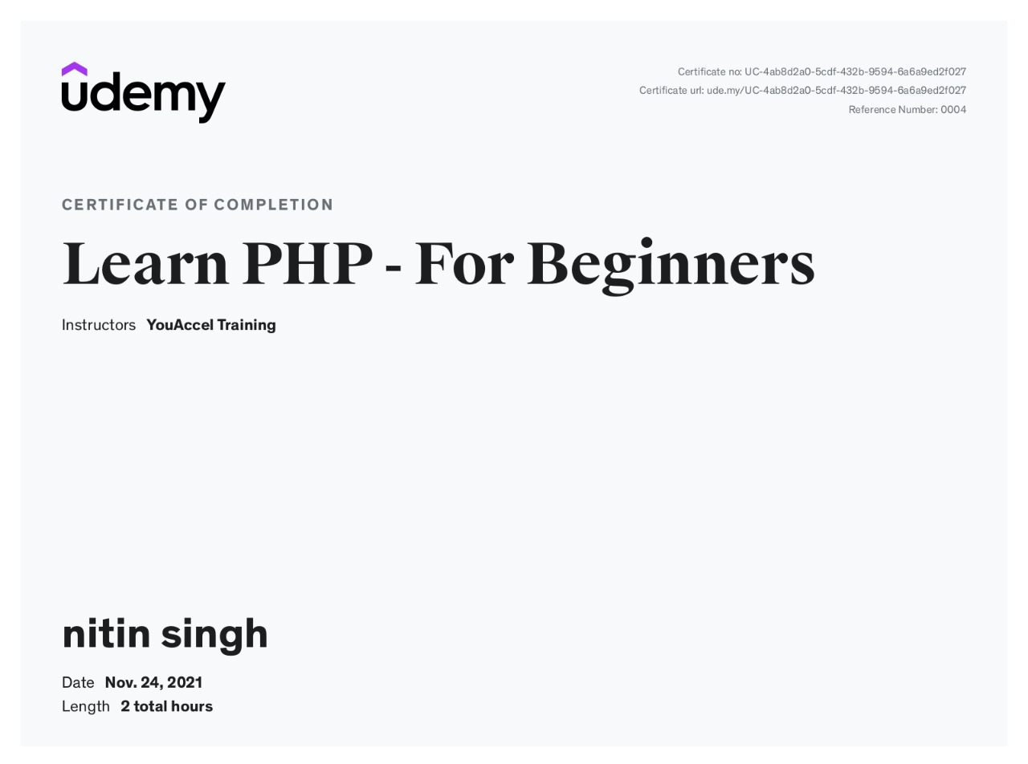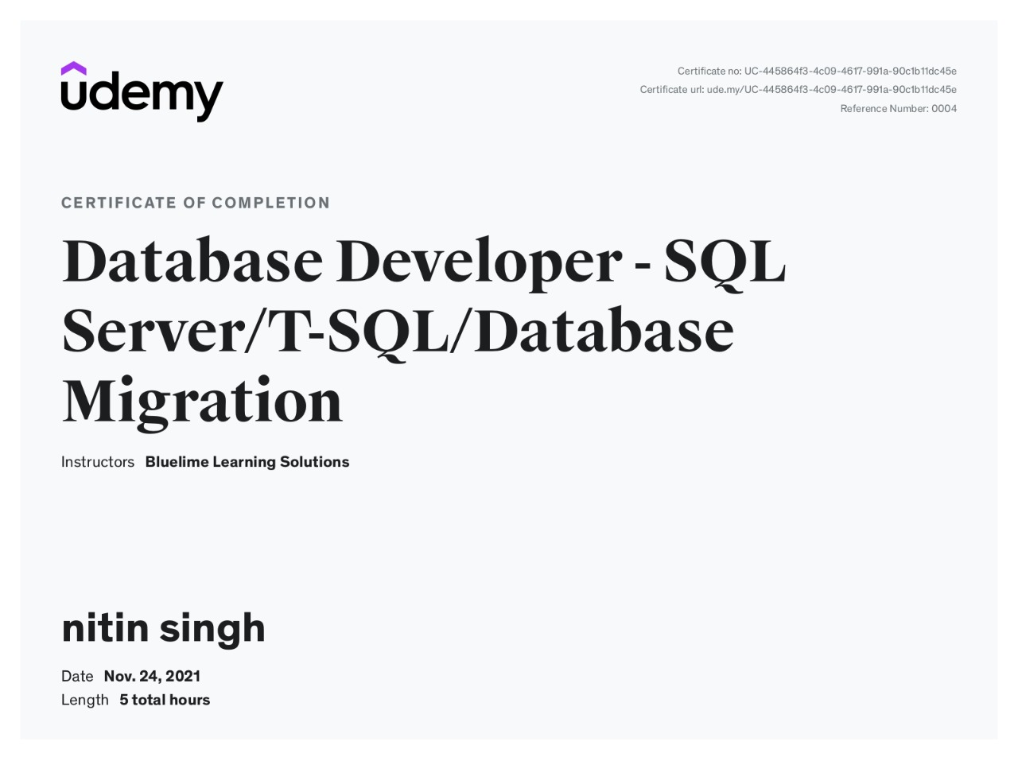

  - Arjun Vyas

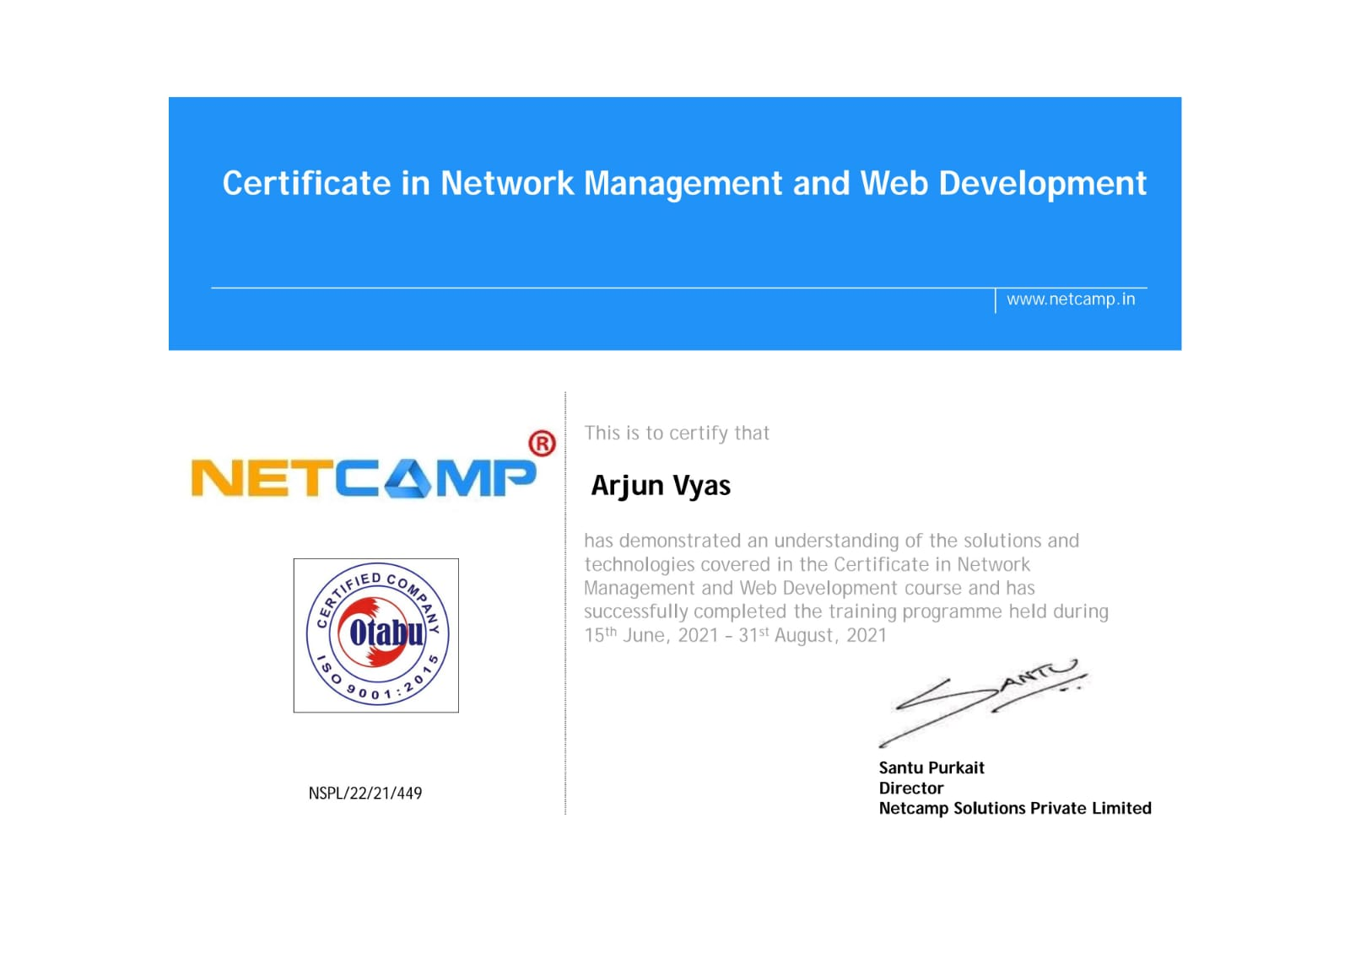

  - Anand Godara


3.Adarsh Solanki


4.Sachin Kumar



Department of Computer Engineering and Applications GLA University, 17 km. Stone NH#2, Mathura-Delhi Road, Chaumuha, Mathura – 281406 U.P (India)

ACKNOWLEDGEMENT

Presenting the ascribed project paper report in this very simple and official form, we would like to place my deep gratitude to GLA University for providing us the instructor Mr Manoj Varshney, our technical trainer and supervisor.

He has been helping us since Day 1 in this project. He provided us with the roadmap, the basic guidelines explaining on how to work on the project. He has been conducting regular meeting to check the progress of the project and providing us with the resources related to the project. Without his help, we wouldn’t have been able to complete this project.

And at last but not the least we would like to thank our dear parents for helping us to grab this opportunity to get trained and also my colleagues who helped me find resources during the training.

Thanking You

Sign: NitinSingh Sign: Arjunvyas
Name of Candidate: Nitin singh Name of Candidate: Arjun vyas

University Roll No.:191500516 University Roll No.:191500147

Sign: AnandGodara Sign: AdarshSolanki
Name of Candidate: Anand Godara Name of Candidate: Adarsh Solanki

University Roll No.:191500 University Roll No.:19150019
Sign: Sachin Kumar

Name of Candidate: Sachin Kumar

University Roll No: 191500
ABSTRACT

In this project, we are creating an Website, basically this is a student management portla which we have named GLA student management System . It is important to know what does a Student Management System Project is and I provide to you the report and abstract of a Student Management system.

Student management systems serve academic institutions in a variety of ways, the most important of which is centralized data administration and accessibility. Teachers will be able to input, maintain, and access student data more simply. Parents and guardians have a better understanding of how their children perform in class.

Teacher and other school or college professionals must enhance their student management skills over time. It is defined as a collection of skills that every teacher develops through time in order to properly manage their students. Getting into the student’s heart is one of the most important aspects of management.

TABLE OF CONTENTS
1. INTRODUCTION 3
1.1 Purpose: 3
1.2 Scope : 4
2. SYSTEM ANALYSIS 5
2.1 Existing System: Student Management System:- 5
2.2 Proposed System - Student Management System 5
2.3 Feasibility Analysis - Student Management System 6
2.3.1 Technical Feasibility: 6
2.3.2 Economical Feasibility 6
3. SYSTEM ARCHITECTURE 8
3.1 Admin Module:- 8
3.2 Staff Module:- 8
3.3 Student Module:- 8
3.4 Services Diagram of Modules. 9
3.5 Data Flow Diagram:- 11
4. OVERALL DESCRIPTION 17
4.1 Product Perspective : 17
4.2 Product Functions : 17
4.3 User Classes and Characteristics : 18
4.4 Operating Environment : 18
4.5 Constraints : 18
4.6 Use Case Model : 19
5. TECHNOLOGY OVERVIEW 27
5.1 PHP 27
5.2 MySQL 27
5.3 Apache 28
5.4 XAMPP 28
5.4.1 Obtaining and Installing XAMPP 28
5.4.2 Creating a Database 29
6. PROJECT DESCRIPTION 31
6.1 Introduction 31
6.2 Description Of Root Directory Contents 32
6.3 Description of Database tables: 34
7. SCREENSHOTS 39
9. BIBLIOGRAPHY 85

- INTRODUCTION
Student Management System is software which is helpful for students as well as the school authorities. In the current system all the activities are done manually. It is very time consuming and costly. Our Student Management System deals with the various activities related to the students.
There are mainly 3 modules in this software
- Administrator Module
- Faculty Module
- Student Module.

In the Software we can register as a faculty as well as a student for every student the authentication code and the roll no is provided by the head of the department faculty and for the registration of a faculty the Registration ID and the authentication code is provided by the administrator the institute.
In this project an admin can manage the faculty and take decision about the students like deletion of any student admin is authorized to create the token for the registration of the faculty as same as a faculty is authorized for creating token for the registration of a student.

1.1 Purpose:

The objective of Student Management System is to allow the administrator of any organization to edit and find out the personal details of a student and allows the student to keep up to date his profile .It’ll also facilitate keeping all the records of students, such as their id, name, mailing address, phone number, DOB etc. So all the information about an student will be available in a few seconds.

Overall, it’ll make Student Information Management an easier job for the administrator and the student of any organization.
The main purpose of this SRS document is to illustrate the requirements of the project Student Management System and is intended to help any organization to maintain and manage its student’s personal data.

1.2 Scope :

Without a Student Management System, managing and maintaining the details of the student is a tedious job for any organization.
Student Management system will store all the details of the students including their background information, educational qualifications, personal details and all the information related to their resume .

SYSTEM ANALYSIS

Existing System: Student Management System:-
System Analysis is a detailed study of the various operations performed by a system and their relationships within and outside of the system. Here the key question is- what all problems exist in the present system? What must be done to solve the problem? Analysis begins when a user or manager begins a study of the program using existing system.
During analysis, data collected on the various files, decision points and transactions handled by the present system. The commonly used tools in the system are Data Flow Diagram, interviews, etc. Training, experience and common sense are required for collection of relevant information needed to develop the system. The success of the system depends largely on how clearly the problem is defined, thoroughly investigated and properly carried out through the choice of solution. A good analysis model should provide not only the mechanisms of problem understanding but also the frame work of the solution. Thus it should be studied thoroughly by collecting data about the system. Then the proposed system should be analyzed thoroughly in accordance with the needs.
System analysis can be categorized into four parts.
- System planning and initial investigation
- Information Gathering
- Applying analysis tools for structured analysis
- Feasibility study
- Cost/ Benefit analysis.
In the current system we need to keep a number of records related to the student and want to enter the details of the student and the marks manually. In this system only the teacher or the school authority views the mark of the student and they want to enter the details of the student. This is time consuming and has much cost.

Proposed System - Student Management System
In our proposed system we have the provision for adding the details of the students by themselves. So the overhead of the school authorities and the teachers is become less. Another advantage of the system is that it is very easy to edit the details of the student and delete a student when it found unnecessary. The marks of the student are added in the database and so students can also view the marks whenever they want.
Our proposed system has several advantages
- User friendly interface
- Fast access to database
- Less error
- More Storage Capacity
- Search facility
- Look and Feel Environment
- Quick transaction

All the manual difficulties in managing the student details in a school or college have been rectified by implementing computerization.

Feasibility Analysis - Student Information Management System
Whatever we think need not be feasible .It is wise to think about the feasibility of any problem we undertake. Feasibility is the study of impact, which happens in the organization by the development of a system. The impact can be either positive or negative. When the positives nominate the negatives, then the system is considered feasible. Here the feasibility study can be performed in two ways such as technical feasibility and Economical Feasibility.

Technical Feasibility:
We can strongly says that it is technically feasible, since there will not be much difficulty in getting required resources for the development and maintaining the system as well. All the resources needed for the development of the software as well as the maintenance of the same is available in the organization here we are utilizing the resources which are available already.

Economical Feasibility
Development of this application is highly economically feasible .The organization needed not spend much money for the development of the system already available.

- SYSTEM ARCHITECTURE
In this chapter, modules of the website are described. It includes software interfaces, hardware interfaces, software requirements, hardware requirements etc.

This project is made under an online project which is works as a website also it also use for the advertisement of the institute it also include the information pages of the institute like vision, about us, history, student information page, syllabus for the students, admission information and a notice board for the student of institute and as well as a guest user.

  - Admin Module:-

This is the first and the base module of the project by this module a admin is provided to the project to manage the faculty and student module. An admin have the authority to add and remove the faculty, Add and delete the Notification, view progress and attendance status of the students, update academic calendar etc.
  - Staff Module:-
This module is for the staff members of the institute all staff are get a unique token no and a pin for registration by the administrator of the institute by using the registration id and pin the faculty will get registration page after filling that form the staff will get registered in the institute database and they choose a password for login to their profile. After login the staff have authorized to services for the student like submit attendance of students, submit marks of their subjects, make result, add notification for a particular department, send mail to individual or a group of student, allot assignments and project to the students.
  - Student Module:-
As like faculty registration same the student will get a roll no and a pin to registered themselves. After enter the roll no and pin students are redirect to the registration page after submitting their general details student will get a roll no and a password to login their profile. After login the student is able to view and update their updatable information like mobile no, email, address and profile pictures but students are restricted to update their key details like Name, Father Name, Date of birth in such a case in student is able to write a online application to their head of department for approving to update these details. Students are able to view other information related to their class like notification of their departments, own attendance in individual subjects, previous test marks, and send message to other students.

  - Services Diagram of Modules.


Add/Update Notification
Add/Delete Staff
Delete Student
View Students Data
Allot Subjects to Staff

ADMIN MODULE

Add Dept. Notification
Add Students
Submit Attendance
Submit Result Data
Allot Assignments
STAFF MODULE

View Attendance
Update Contact Details
View Marksheet
Message to Classmates
View/Submit Assigments

STUDENT MODULE

Admin Module
Staff module
Student module process
Database
Administrator
Request to Login
Login granted
Request to edit
Request to view
Staff
Request to Login
Request to edit
Request to view
Staff
Request to Login
Request to edit
Request to view

    - INTRODUCTION:
An entity–relationship model (ER model) describes inter-related things of interest in a specific domain of knowledge. An ER model is composed of entity types (which classify the things of interest) and specifies relationships that can exist between instances of those entity types. In software engineering an ER model is commonly formed to represent things that a business needs to remember in order to perform business processes. Consequently, the ER model becomes an abstract data model that defines a data or information structure that can be implemented in a database, typically a relational database.
Entity–relationship modeling was developed for database design by Peter Chen and published in a 1976 paper. However, variants of the idea existed previously, some ER modelers show super and subtype entities connected by generalization-specialization relationships, and an ER model can be used also in the specification of domain-specific ontology.
An ER model is typically implemented as a database. In a simple relational database implementation, each row of a table represents one instance of an entity type, and each field in a table represents an attribute type. In a relational database a relationship between entities is implemented by storing the primary key of one entity as a pointer or "foreign key" in the table of another entity There is a tradition for ER/data models to be built at two or three levels of abstraction. Note that the conceptual-logical-physical hierarchy below is used in other kinds of specification, and is different from the three schema approach to software engineering.

    - Conceptual data model:
This is the highest level ER model in that it contains the least granular detail but establishes the overall scope of what is to be included within the model set. The conceptual ER model normally defines master reference data entities that are commonly used by the organization. Developing an enterprise-wide conceptual ER model is useful to support documenting the data architecture for an organization.
    - Logical data model:
A logical ER model does not require a conceptual ER model, especially if the scope of the logical ER model includes only the development of a distinct information system. The logical ER model contains more detail than the conceptual ER model. In addition to master data entities, operational and transactional data entities are now defined. The details of each data entity are developed and the relationships between these data entities are established. The logical ER model is however developed independent of technology into which it can be implemented.
    - Physical data model:
One or more physical ER models may be developed from each logical ER model. The physical ER model is normally developed to be instantiated as a database. Therefore, each physical ER model must contain enough detail to produce a database and each physical ER model is technology dependent since each database management system is somewhat different.

- OVERALL DESCRIPTION
  - Product Perspective :
The website Student Information Management System is aimed towards recording a considerable number of student records and needs online assistance for managing records of students. Website should be user-friendly, ‘quick to learn’ and reliable website for the above purpose.

Student Information System is intended to be a stand-alone product and should not depend on the availability of other website. The system will also have an administrator who has full-fledged rights with regards to performing all actions related to control and management of the website.

  - Product Functions :

There are three different users who will be using this product:
- Administrator who can view and edit the details of any students & Staff
- Faculty who can view and edit the details of students.
- Students who can view their details as well as they can edit their details.

The features that are available to the Administrator are:

- An Administrator can login into the system and perform any of the available operations.
- Can enable/disable student.
- Can add & remove front page notifications.
- Can add & remove the faculty as well as student.
- Can edit student information to the database. Can make search for a specific student.
- Add & Update Academic calendar.
- Allocate the subjects to the faculty.
- Can access all the details of the student.

The features that are available to the faculty are:-

- Can submit attendance of the students.
- Can Submit students exam or Test marks.
- Can Add & Remove Departmental Notifications.
- Update self Profile Details

The features that are available to the Students are:-

- View their attendance in individual subjects.
- View their test or exam marks.
- Update their basic contact details.
- Send or view the message to the classmates.
- View the departmental notification which they are belongs to.
- Submit Leave application or other application.

  - User Classes and Characteristics :

There are mainly three kinds of users for the product.

The users include:
- Administrator
- Staff
- Student

  - Operating Environment :

The product can run on any browser (preferable to use Chrome browser).

  - Constraints :

Every user must be comfortable using computer.

All operations are in English so user must have basic knowledge of English.

Use Case Model

- Administrator: Responsible for managing faculty records.

- Login into the website
- Add / Remove Notification
- Add / Remove staff.
- Allocate Subjects to staff.
- Search student details
  - Display student details
  - Enable/Disable student

- Staff : Responsible for managing Students records.
- Submit attendance of the students.
- Submit Marks of the students.
- Add/Remove departmental notifications.
- view & update profile of self.

- Student: Has the access rights to view and edit their personal details.

- Login into the website .
- Display student details
- Edit their details .
- View their attendance .
- View their results .
- Message to classmates.
- View departmental notifications.

- Assumptions & dependencies

- Administrator is created in the system already.

- Roles and tasks are predefined.

- Specific Requirements :

Use Case Reports

Administrator: Responsible for managing student details.
Use-case: Login into the website
Goal in context: Gain access to the website
Brief Description: This use case is used when the administrator wants to access the website to enable/disable/update the personal details of the student.
Preconditions: The Administrator must be logged onto the website in order for this use case to begin.
Basic Flow:
The Website prompts the administrator for the user name and password. The Administrator enters the user name and password. The Website verifies the password and sets the user’s authorization. The Administrator is given access to the Website to perform his tasks.
Alternative Flow:
The administrator enters invalid username and password then he will not be allowed to enter the website.
Post conditions: The website state is unchanged by this use case.

Use Case : Display student details
Goal in context: View the details of a student
Brief Description: This use case is used when the administrator wants to view the facilitate the services to the faculty and view the status of the students.
Preconditions: The Administrator must be logged into the system in order for this use case to begin The details of the student must pre-exist in the database The student id must be entered correctly.
Basic Flow:
The Administrator logs onto the System.
- Notification Service :-
  - Admin can add the notification by the help of notification add page in this page the admin just add the title of the notification and the upload the related pdf or document file of that notification.
  - This notification is visible on the homepage.
  - These notifications are accessible by all the user who visited on the website.
  - Admin can easily delete the notification.
- Staff management :-
  - In this section an admin can manages the faculty .
  - After login admin can generate token for the faculty. In tis token the admin allot a registration id and the pin related with the faculty name.
  - After generation of the token page is redirect to the admin page.

. Faculty : Responsible for managing student details.
Use-case: Login into the website
Goal in context: Gain access to the website

Brief Description: This use case is used when the faculty wants to access the website to enable/disable/update the personal details of the student.

Preconditions: The faculty must be logged onto the website in order for this use case to begin.

Basic Flow:
The Website prompts the faculty for the user name and password. The faculty enters the user name and password. The Website verifies the password and sets the user’s authorization. The faculty is given access to the Website to perform his tasks.

Alternative Flow:
The faculty enters invalid username and password then he will not be allowed to enter the website.

Post conditions: The website state is unchanged by this use case.

Goal in context: View the details of a student

Brief Description: This use case is used when the faculty wants to view the facilitate the services to the faculty and view the status of the students.

Preconditions: The faculty must be logged into the system in order for this use case to begin The details of the student must pre-exist in the database The student id must be entered correctly.

Basic Flow:
The faculty logs onto the System.

- Submit Attendance :-

  - Faculty can submit the attendance for every student in subject who is allotted by the administrator.

  - For submit attendance faclty has to navigate the submit attendance page.

  - There is two way available to submit the attendance.
    - Submit attendance in list view.
    - Quick attendance submit mode.

  - To submit attendance in list view faculty have to select the class and then the subject.

  - Then page is navigated to submit attendance page in this page the list of the student is visible which are belongings to selected subject.

  - To save a student as a present just tick the checkbox and to absent the student just uncheck the checkbox.
- Submit marks:
  - To submit the marks for student faculty has to navigate the page by choosing submit marks option of menu from the faculty page.
  - There are two way to submit marks of students.
    - Submit marks to each student in list mode.
    - Submit marks by uploading the excel file.
- Add/Remove Notification.
  - Faculty can add the notification by the help of notification add page in this page the faculty just add the title of the notification and the upload the related pdf or document file of that notification.
  - This notification is visible on the homepage.
  - These notifications are accessible by all the user who visited on the website.
  - Faculty can easily delete the notification.
- Student management :-
  - In this section an admin can manages the Student.
  - After login admin can generate token for the student. In tis token the faculty allot a Roll No and the pin related with the student name.
  - After generation of the token page is redirect to the faculty page.

Post conditions:
The token is generated by the faculty is used by students to signup the students. And the databse of the marks table and attendance table is updated.

- TECHNOLOGY OVERVIEW

The technology selected for implementing Student Information Management System is PHP/MYSQL.Apache is used as the HTTP server.The development was done in a ‘windows’ environment using adobe dreamweaver CS5.

  - PHP

PHP is a general-purpose scripting language that is especially suited to server-side web development where PHP generally runs on a web server.PHP code is embedded into the HTML source document.Any PHP code in a requested file is executed by the PHP runtime, usually to create dynamic web page content.It can also be used for command-line scripting and client-side GUI applications. PHP can be deployed on many web servers and operating systems, and can be used with many relational database management systems (RDBMS). It is available free of charge, and the PHP Group provides the complete source code for users to build, customize and extend for their own use.

  - MySQL

MySQL is a relational database management system (RDBMS) ^{[1]} that runs as a server providing multi-user access to a number of databases. MySQL is a popular choice of database for use in web applications and is an open source product. The process of setting up a MySQL database varies from host to host, however we will end up with a database name, a user name and a password. Before using our
database, we must create a table. A table is a section of the database for storing related information. In a table we will set up the different fields which will be used in that table. Creating a table in phpMyAdmin is simple, we just type the name, select the number of fields and click the ‘go’ button. we will then be taken to a setup screen where you must create the fields for the database.Another way of creating databases and tables in phpMyAdmin is by executing simple SQL statements.We have used this method in order to create our database and tables.

  - Apache

The Apache HTTP Server is a web server software notable for playing a key role in the initial growth of the World Wide Web. In 2009 it became the first web server software to surpass the 100 million web site milestone. Apache is developed and maintained by an open community of developers under the auspices of the Apache Software Foundation. Since April 1996 Apache has been the most popular HTTP server software in use. As of November 2010 Apache served over 59.36% of all websites and over 66.56% of the first one million busiest websites.

  - XAMPP

XAMPP is a small and light Apache distribution containing the most common web development technologies in a single package. Its contents, small size, and portability make it the ideal tool for students developing and testing applications in PHP and MySQL. XAMPP is available as a free download in two specific packages: full and lite. While the full package download provides a wide array of development tools, XAMPP Lite contains the necessary technologies that meet the Ontario Skills Competition standards.The light version is a small package containing Apache HTTP Server, PHP, MySQL, phpMyAdmin, Openssl, and SQLite.

    - Obtaining and Installing XAMPP

As previously mentioned, XAMPP is a free package available for download and use for various web development tasks. All XAMPP packages and add-ons are

distributed through the Apache Friends website at the address: http://www.apachefriends.org/. Once on the website, navigate and find the Windows version of XAMPP and download the self-extracting ZIP archive. After downloading the archive, run and extract its contents into the root path of a hard disk or USB drive. For example, the extract path for a local Windows installation would simply be C:\. If extracted properly we will notice a new xampp directory in the root of your installation disk. In order to test that everything has been installed correctly, first start the Apache HTTP Server by navigating to the xampp directory and clicking on the apache_start.bat batch file.
Next we will test if the server is running correctly by opening an internet browser and typing http://localhost/ into the address bar. If configured correctly, we will be presented with a screen similar to that of the one below.
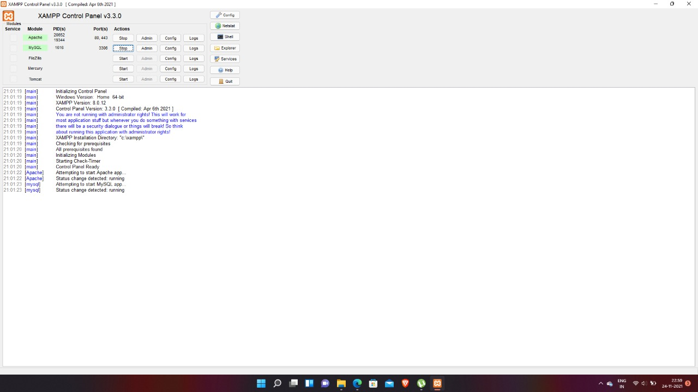
In order to stop all Apache processes we do not close the running terminal application, but instead run another batch file in the xampplite directory called apache_stop.bat.

    - Creating a Database and Inserting Data

Now that we have run and tested Apache and PHP, the next step is running MySQL and creating a database and table which will hold information to be used by our website. In order to start MySQL, navigate to the xampp directory and run the mysql_start.bat batch file.The XAMPP package contains an application called phpMyAdmin which allows developers to administer and maintain MySQL databases.We will be using phpMyAdmin to create a database and table, and enter test data. Before testing phpMyAdmin, make sure that both Apache and MySQL are running by opening their respective batch files: apache_start.bat and mysql_start.bat. Along with Apache and MySQL running in the background, we type http://localhost/phpMyAdmin/ into our web browser. If successful we will be presented with a phpMyAdmin start page similar to the one shown below.
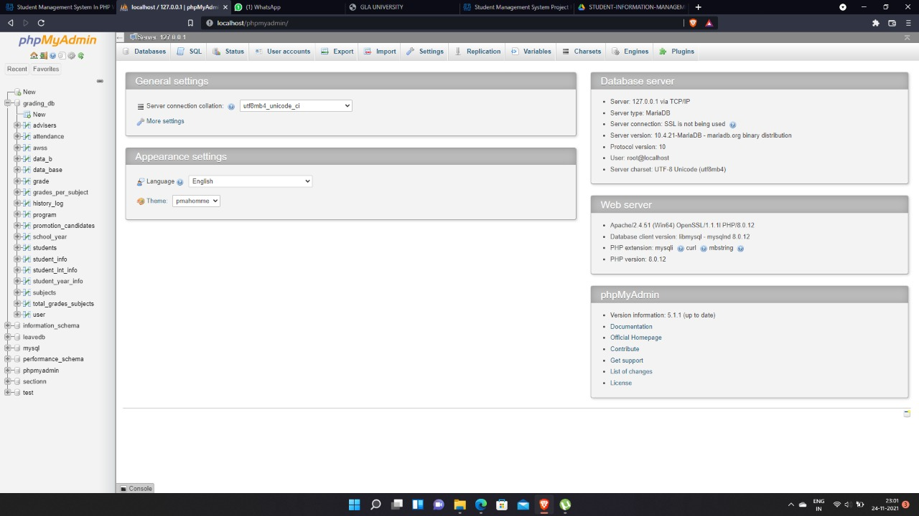
The first step with phpMyAdmin running is creating a new database.We create a new database by directly executing SQL statements as shown below.The successful execution of the sql querry creates a database ‘sims’ with tables in it.The tabels are admin_login and student_info. We also inserted values in the admin table.The screenshot below shows the successful execution of the query thus creation of a database named student.

- PROJECT DESCRIPTION

Login page

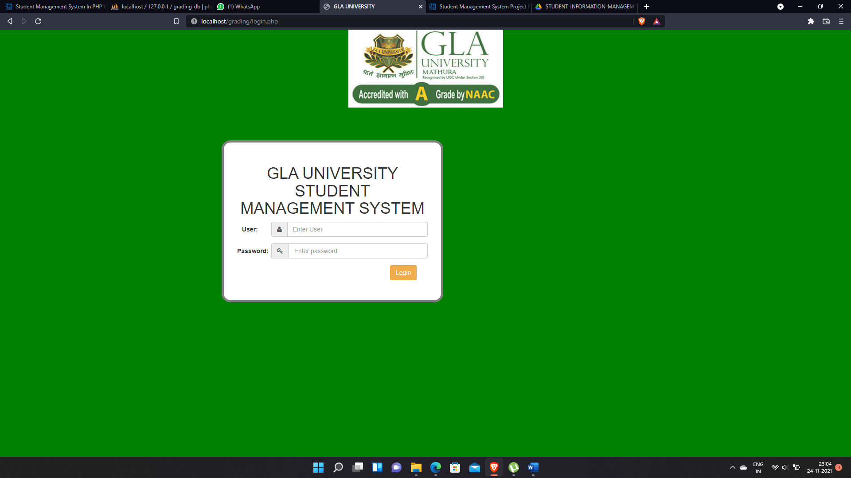

Dashboard

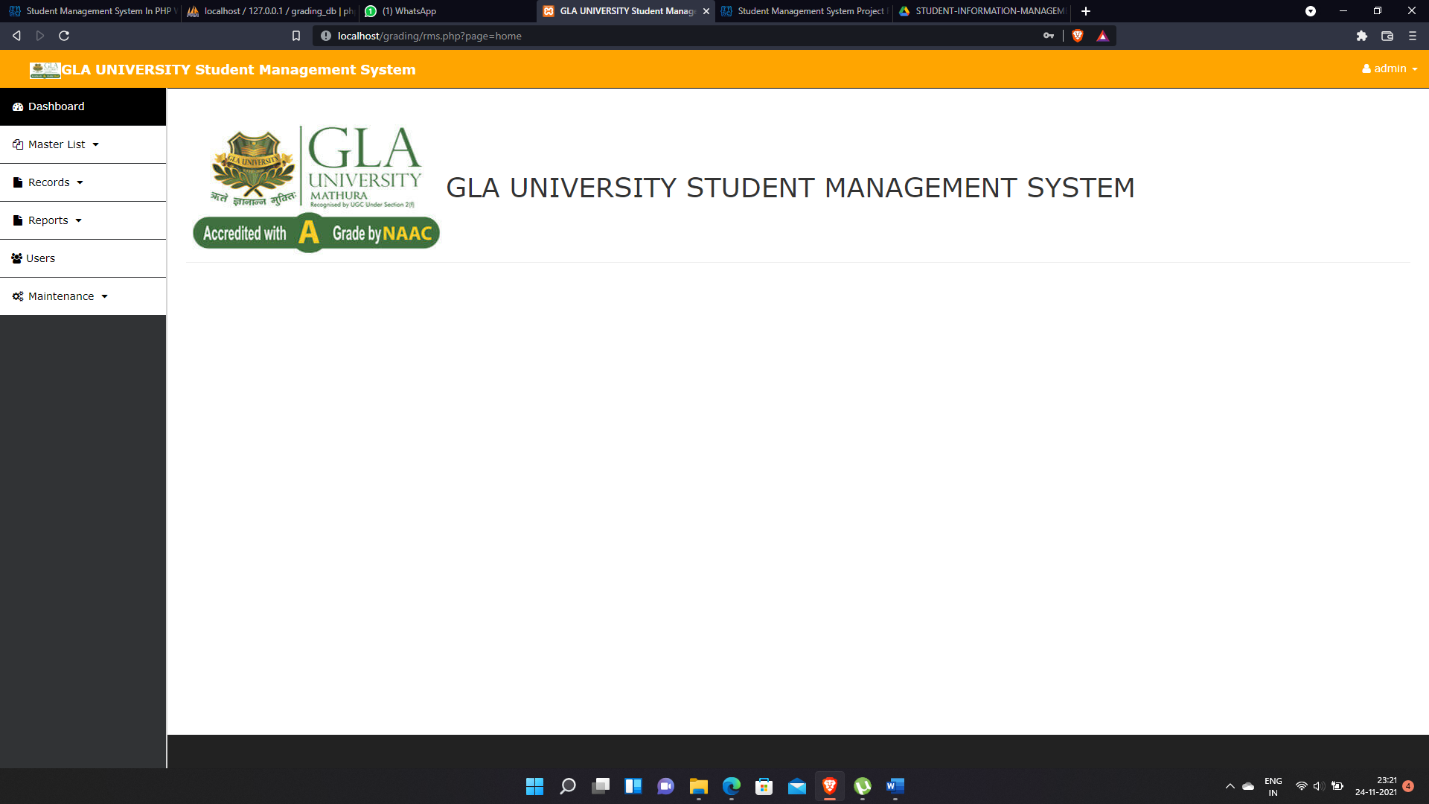

Student list Page

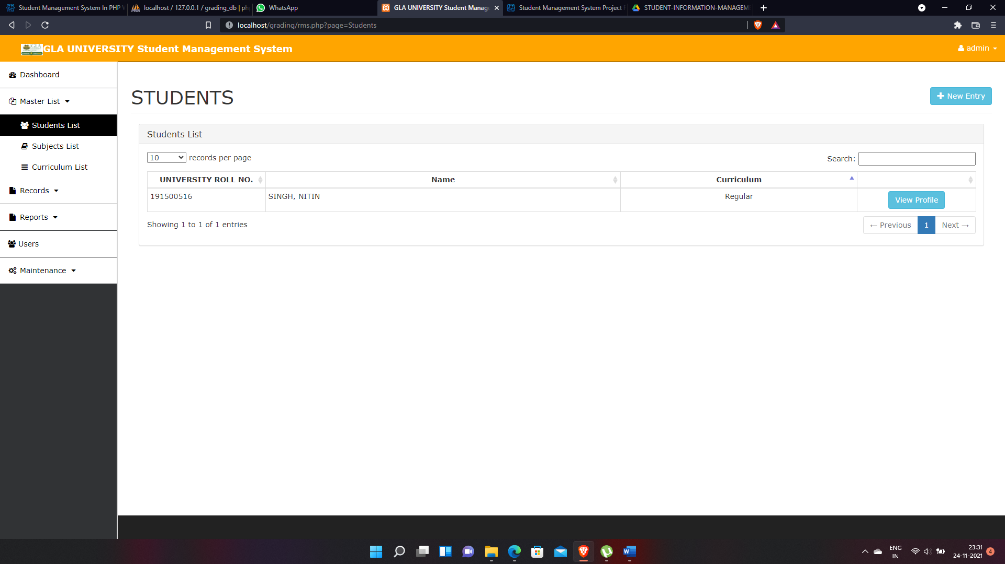

New entry

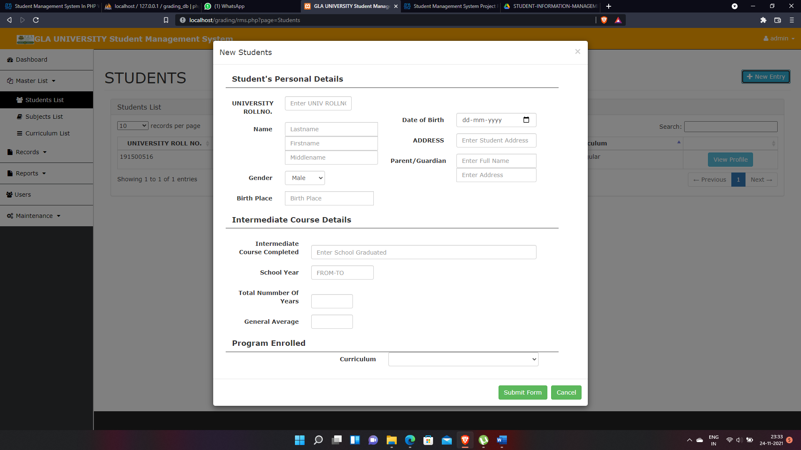

Subjects list Page

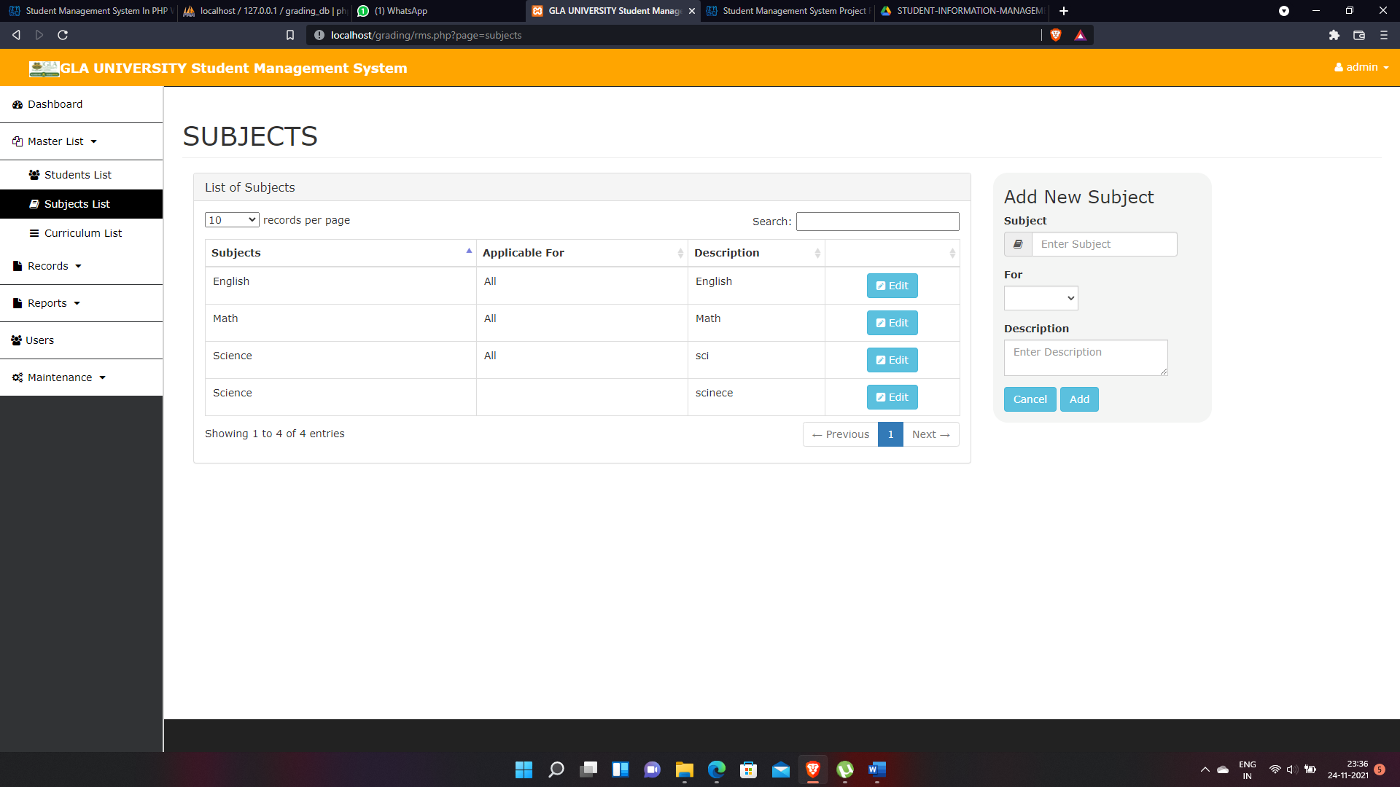

Curriculum list Page

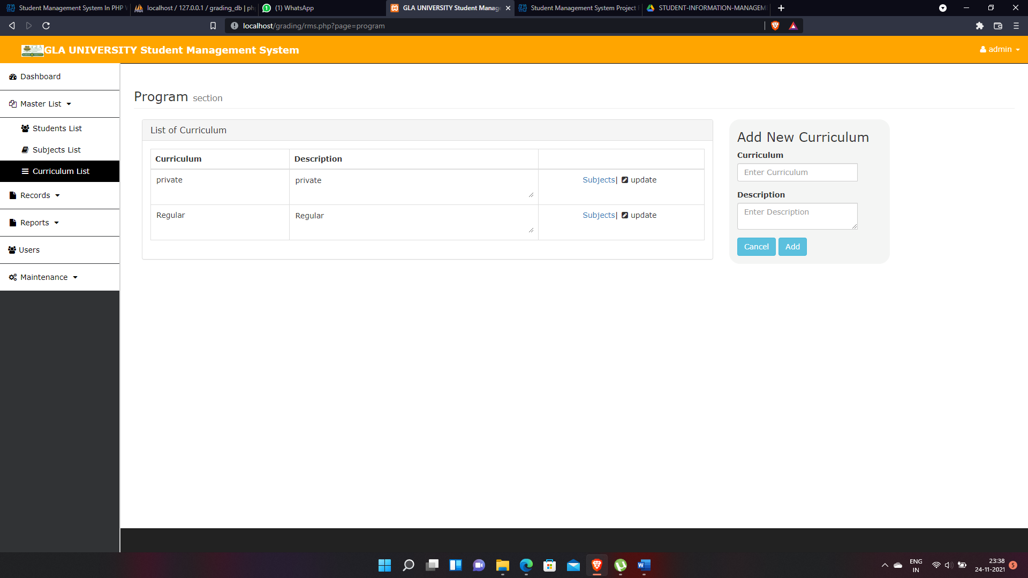

Academic Record Page

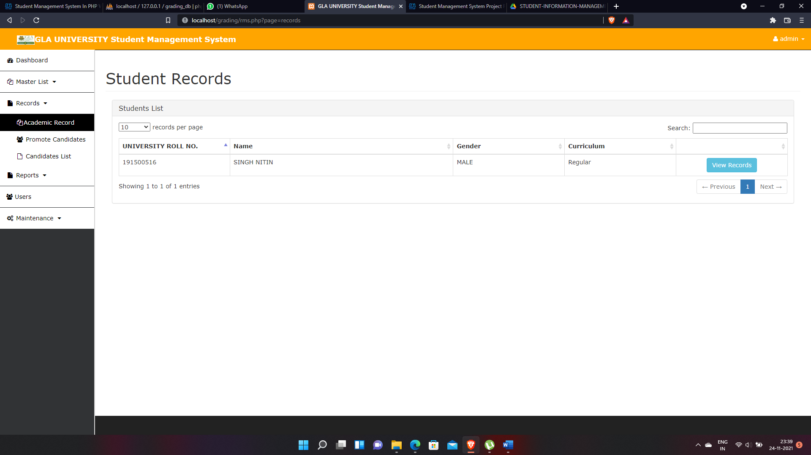

Promote students page

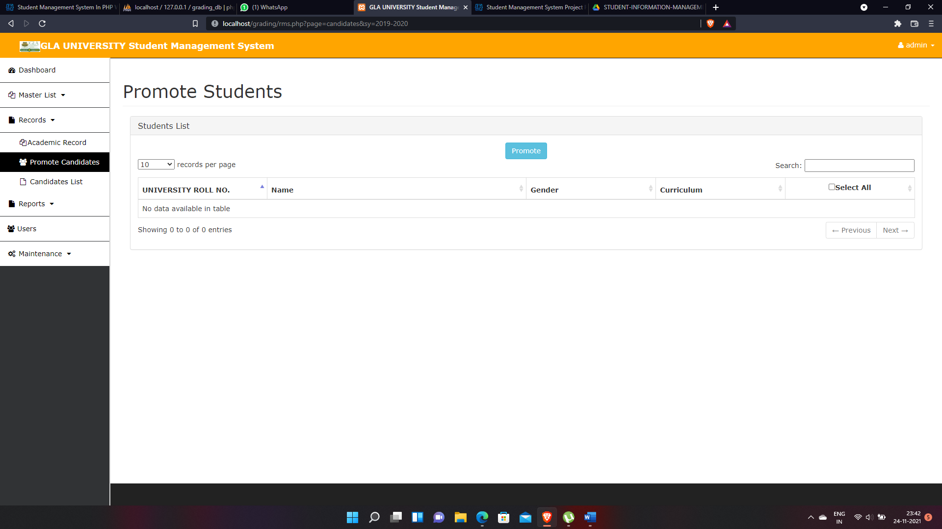

Promoted student list

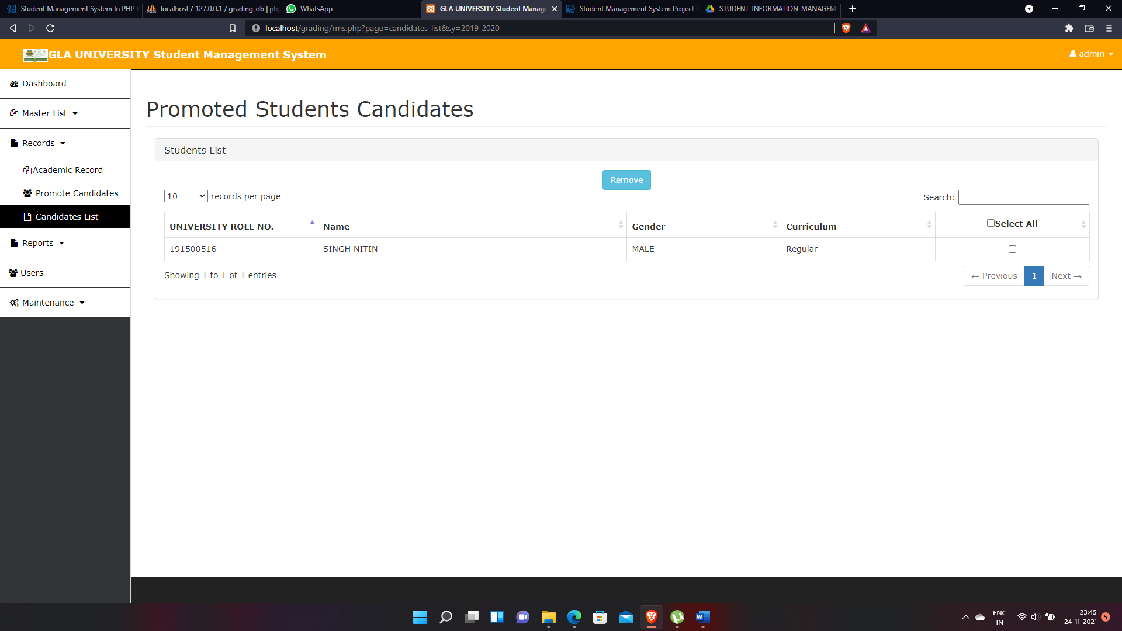

Search Student Record

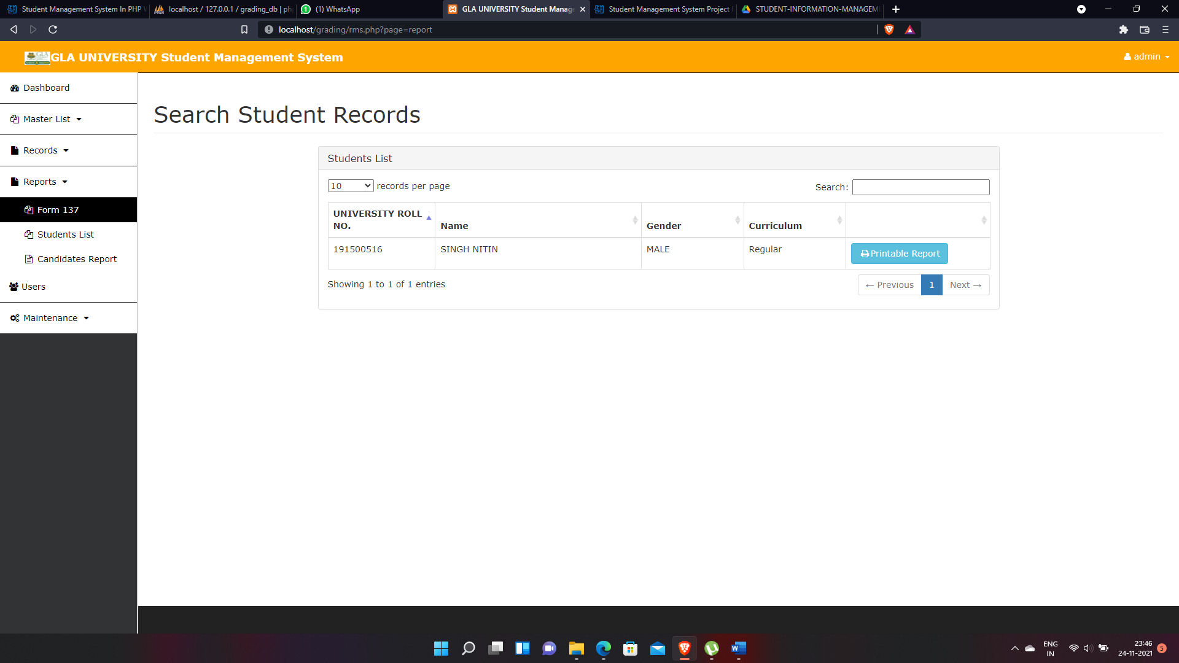

Search Student record by school year

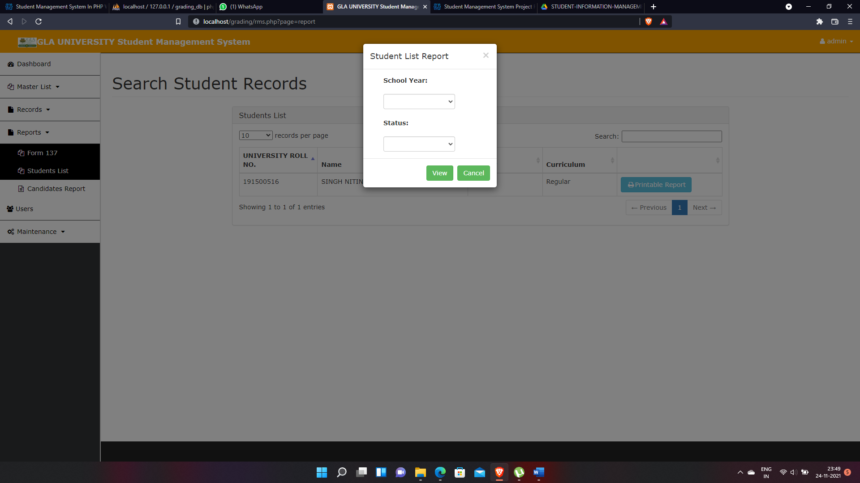

Candidate Report

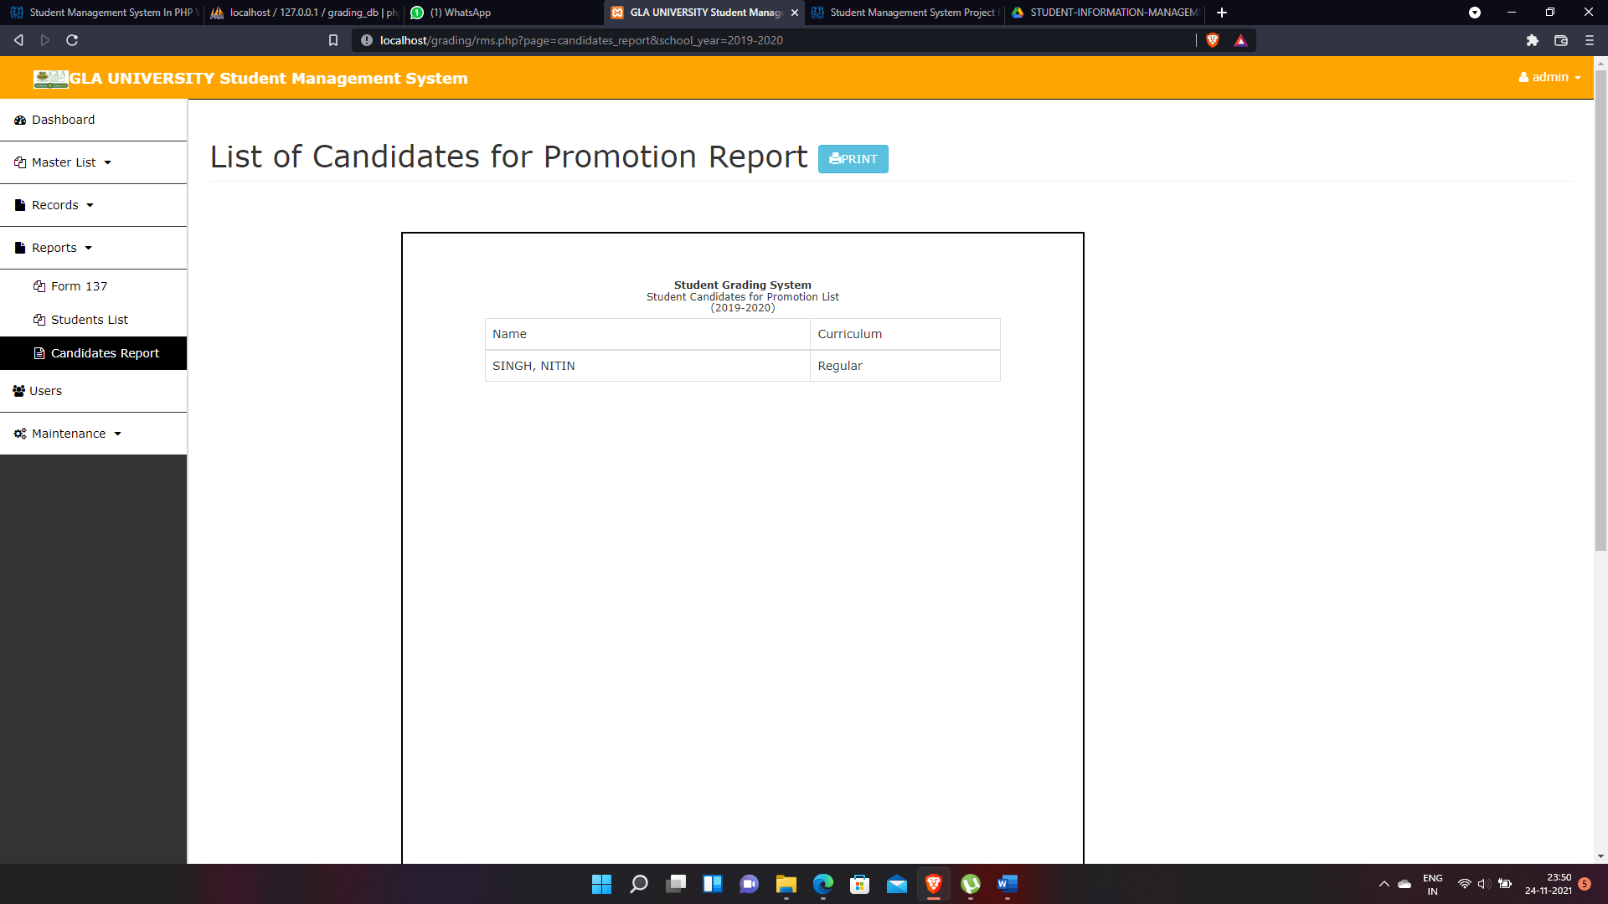

Add new user

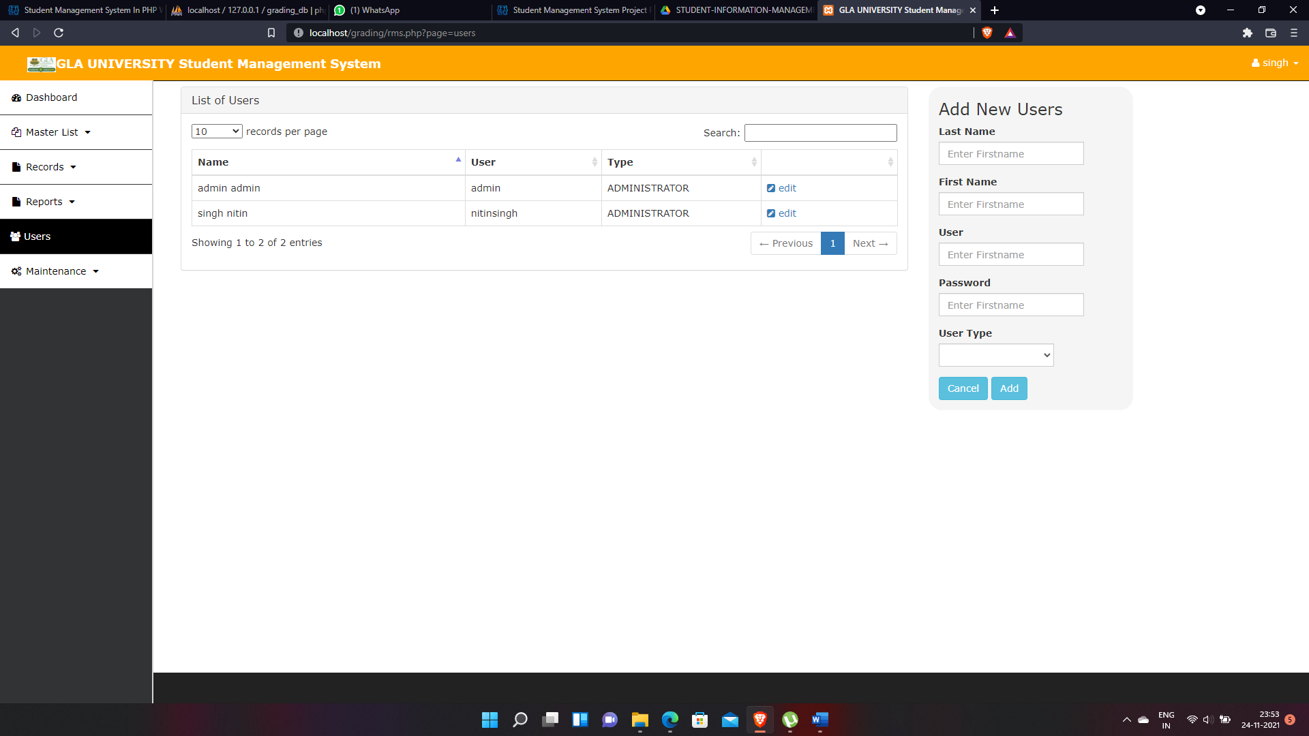

School year page

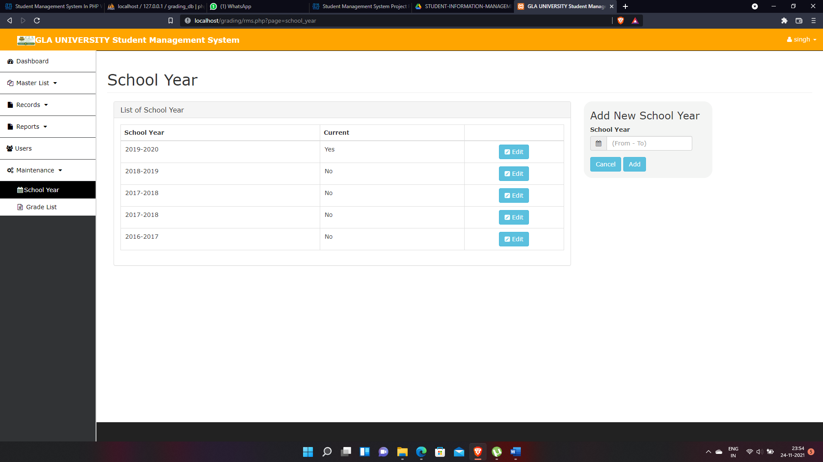

Grade list page

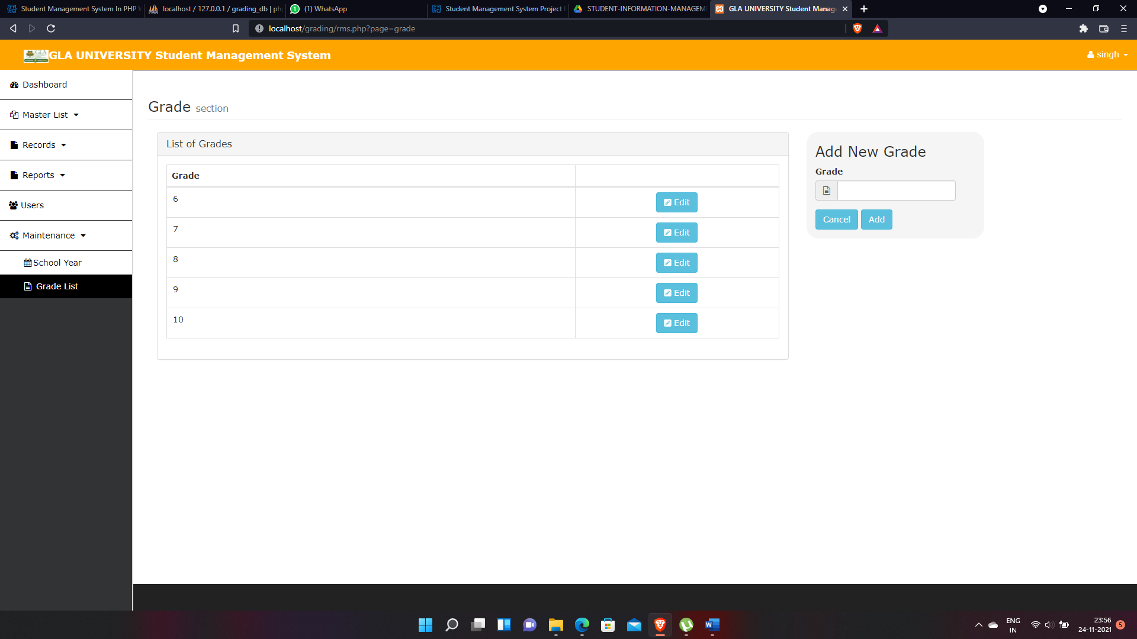

Logout button and account button

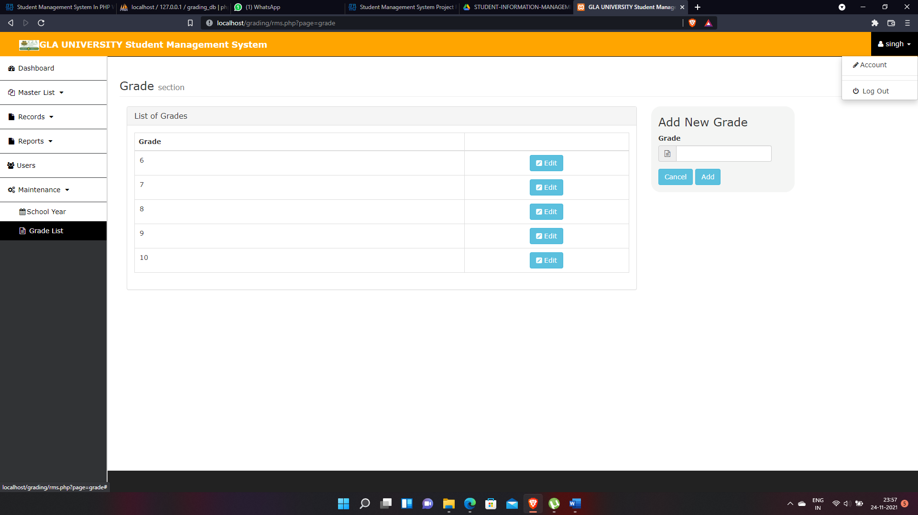

CONTRIBUTION IN THE PROJECT

Student information management system lead to a better organization structure since the information management of the students is well structured and also lead to better as well as efficient utilization of resources.

Student Management System can be used by education institutes to maintain the records of students easily. Achieving this objective is difficult using a manual system as the information is scattered, can be redundant and collecting relevant information may be very time consuming. All these problems are solved using this project

Our project Student Management System was developed by all three of us. We, a team of three persons took a step by step approach in order to reach our goal. We applied the knowledge we gained during our training period at Creative Net pvt. Ltd.. and developed this project “STUDENT MANAGEMENT SYSTEM”.

- NON- FUNCTIONAL REQUIREMENT :

  - Performance Requirements:

The proposed system that we are going to develop will be used as the Chief performance system for providing help to the organization in managing the whole database of the student studying in the organisation. Therefore, it is expected that the database would perform functionally all the requirements that are specified.

  - Safety Requirements:

The database may get crashed at any certain time due to virus or operating system failure. Therefore, it is required to take the database backup.

  - Security Requirements:

We are going to develop a secured database. There are different categories of users namely Administartor ,Student who will be viewing either all or some specific information form the database.
Depending upon the category of user the access rights are decided. It means if the user is an administrator then he can be able to modify the data, append etc. All other users only have the rights to retrieve the information about database.

- BIBLIOGRAPHY

We have learn most of the things from our mentor xxxxx and He helped us a lot

to make this project . We also take help of udemy courses and netcamp web development course .

For php knowledge

https://www.udemy.com/course/learn-php-for-beginners-n/learn/lecture/14519032?start=120#overview

For sql data base knowledge

https://www.udemy.com/course/database-developer-sql-servert-sqldatabase-migration/learn/lecture/14875878?start=15

